CASE STUDY OF APPLIED PHYSICS

1. You have a Dictionary of a car of different models and their specifications, you have to compute the velocity, Acceleration, Force cars make, Kinetic Energy and average power of a car both on plane surface and on inclined plane through their Distance, mass and time. Then save them in that Dictionary.

Cars = {  
 **"brand"**: [**"Ford"**,**"Ford"**,**"Ford"** , **"Ford"** ],  
 **"model"**: [**"Mustang"**,**"EcoSport"** ,**"Endeavour"** , **"Figo"** ],  
 **"Displacement"**: [4951,1498 , 2198 , 1194],  
 **"Mass"** : [3800 , 4230 , 3500 , 3859]  
}

|  |  |
| --- | --- |
| Motion specifications | fORMULA |
| Velocity | $$Velocity = Distance / Time$$ |
| Displacement |  |
| Acceleration |  |
| Force |  |
| Kinetic Energy | m = Mass  v = velocity |
| Average power on plane surface |  |
| Average power on inclined plane | Where W is weight of Car W =mass x gravity  V is maximum velocity  Theda is a angel of inclined plane |

**Numerical:** Incline Plane Numerical A car of weight 3000N possesses an engine whose maximum power output is 160kW. The maximum speed of this car on a level road is 35m/s. Assuming that the resistive force (due to a combination of friction and air resistance) remains constant, what is the car's maximum speed on an incline of 1 in 20 (i.e., if $\theta$ is the angle of the incline with respect to the horizontal, then $\sin\theta = 1/20$)?

CASE STUDY OF MATHEMATICS

1. Take a shape name, parameters from user as a input, compute the area, Perimeter, Radius, Diameter, Volume, length of slant of different shapes of geometry given in Formula Sheet.

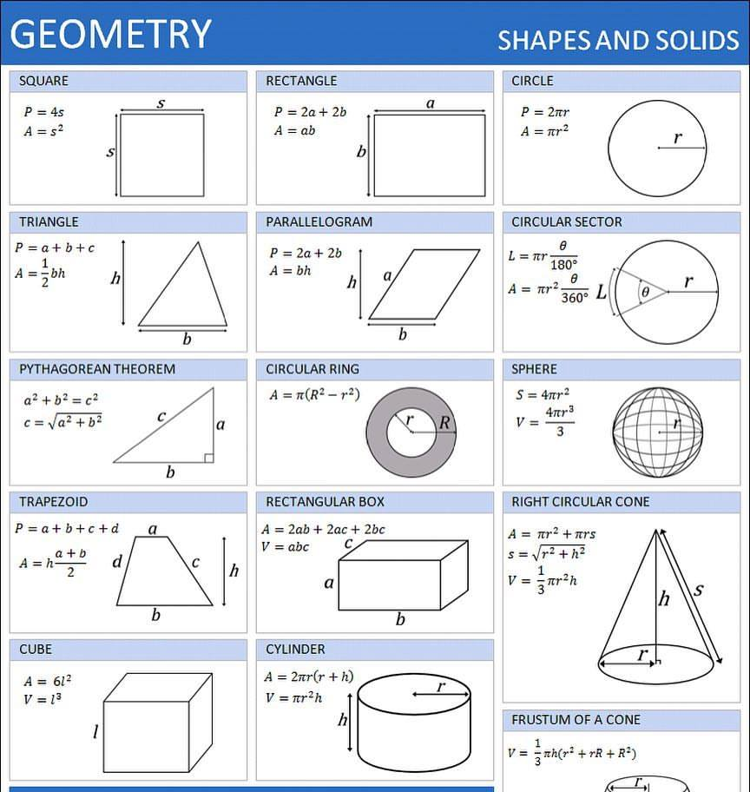

CASE STUDY OF MEDICAL

Create a Typhoid Diagnosis program in which take dictionary of physical symptoms and laboratory test symptoms use if else statements and loops to analyze and compare every user defined symptom with the build in dictionary and Show the diagnosis.

|  |  |
| --- | --- |
| Signs |  |
| Symptoms |  |
| Test results |  |

CASE STUDY OF FINANCE

1. Make a Program for List of Loan data, where interest rate is given in the form of tuples and payback time periods/years are given in sets, compute the simple interest, compound interest, effective rate, Amortized loan payment and remaining balance.

